**Submitting Health Insurance Information to Medical Providers:**

**(Via Chartswap or through the phone)**

* **Gather Relevant Information:**
* Collect all necessary health insurance details,(pictures of front and back of HI cards) including policy number, group number, and any other pertinent information.
* **Phone Submission Steps:**
* Call the medical provider's billing department.
* Clearly state your purpose and express your intention to provide health insurance information.
* Provide all required details accurately, including policy and group numbers.
* **Chartswap Submission Steps:**
* Access the Chartswap platform and log in to your account.
* Identify the specific medical provider for submission.

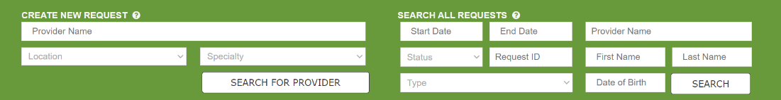

* **Enter Information on Chartswap:**
* Input the required CL’s information
* A screenshot of a computer

  Description automatically generated

select the insurance update option.

* **Upload Supporting Documents:**
* Click next and upload any supporting documents related to health insurance coverage, such as copies of insurance cards (front and back) and HIPPA

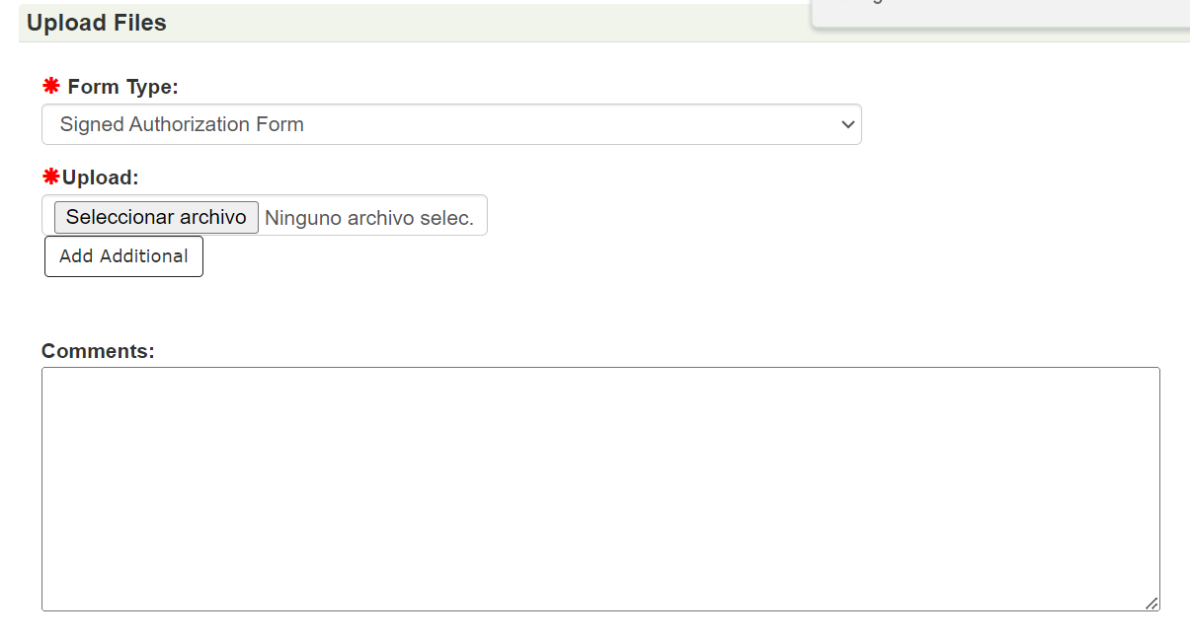

* **Submit**
* Once you have reviewed all the information is there you can submit the request

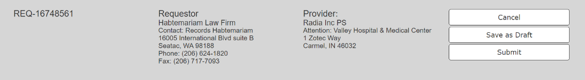

* **Follow-Up:**
* After submission, follow up with the medical provider to ensure they have received and processed the health insurance information.
* Address any additional requests or inquiries promptly.
* **Documentation:**
* Record the submission details, including dates, times, and any reference numbers, in your records for future reference.