How to Request Wage Loss Records & Authorization

Index:
Step 1: After client is done treating ask them if they missed work due to pain or treatment
Step 2: Have client sent 2 months of pay stubs
Step 3: Fill out Wage loss Authorization and submit to chiropractor

How to Request Wage Loss Records & Authorization

Step 1: After client is done treating ask them if they missed work due to pain or treatment.
- If client did miss work find out exactly how many days, and from what day to what day.
Step 2: Have client send 2 months of pay stubs.
- If they are not able to get pay stubs they will need a letter from employer that shows client missed the amount of work days the client stated without pay.
- They can also submit screen shots if they worked for companies like Uber or Lyft.
Step 3: Fill out Wage loss Authorization form along with the cover letter and submit to chiropractor.
- Cover letter needs to be on the law firm’s layout
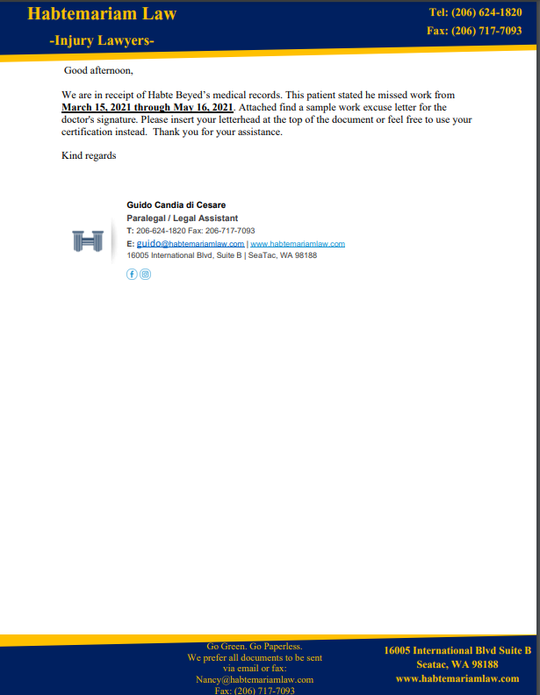
- Make sure you put the clients name and the exact days client missed.
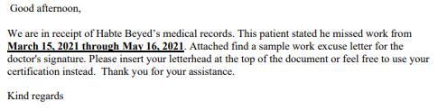
- On the Wage loss Authorization Have the clients name, DOB, and date of loss at the top
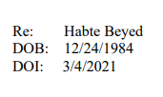
- Also have in the paragraph you update clients name date of loss and the amount of days client missed.
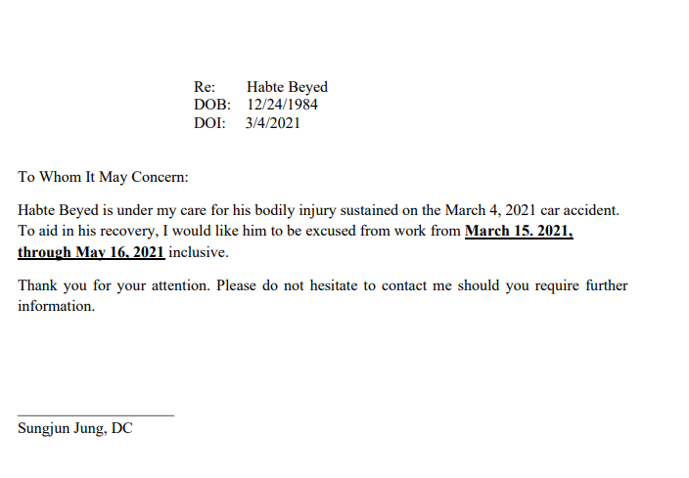
- Finally have the doctors name at the bottom to sign or the name of the chiropractic office name.

