Drafting a Summons
(All cases but Texas)
Step 1- Really easy, open up DOC 22, do the copy paste to new word doc trick, and change the highlighted portions.
- Change
  - Header
  - Plaintiff(s) name in first line
  - Date at bottom

Texas Cases- Everything in Texas is much more complicated and expensive for no reason. Try not to get frustrated.
Step 1- NO SUMMONS AT ALL. In Texas, they file “Citations” with a complaint instead. View DOC 33.
Step 2- Change the obvious information. You won’t have a cause #.
- Which court
- Parties and their information, including addresses.
- Leave Jane/John Doe the way it is short of last name.
Step 3- Eventually, the court will email us a certified/filed citation that looks nothing like what you just submitted. That is the final product and treat it as a summons in all contexts. See DOC 34.

Drafting a Complaint (Car Cases)

Step 1- Gather Relevant documents such as Police Reports, LOR, or anything that has facts of the case. This could be in Chiro notes sometimes.
Step 2- Make sure you know who you are suing, there are almost always multiple LORs on file or other information. Either check the demand or figure it out from the facts.
Note- If there is a police report, you can search all names in FV, especially PASSENGERS, to see if we have retained other parties to include in the lawsuit. See below.

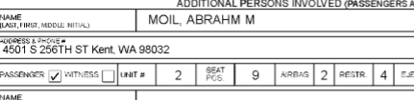

Step 3- Open up DOC 21.
  - Highlight 1 letter or word with your mouse.
  - Hit the following sequence on your keyboard- “ctrl A”, then “ctrl C.”
  - Open a blank word page. Hit “ctrl V”.
    - Now you have a fresh copy to change, and you won’t accidentally change the template. I do this same thing for pleadings or really any legal docs.
Step 4- Change Information that is highlighted.
  - You won’t have a case number until after you file. If it’s King or Pierce County, you’ll get it immediately. If it’s one of the other counties, it’ll take a few days.
  - The parties’ locations can be obtained on police reports. Google the city and look up the county it’s in. If there isn’t information available on 3p, just say same as Plaintiff and add “or where he/she may be found.”
Step 5- Subsection “III. Facts of the Accident,” creating a short story advice-
  - Start the first line always with the following and in this order-
    - The date of injury, time if possible (“on or around 10:33 PM”),
    - Introduce the Plaintiff (“Plaintiff Thiara was….”)
    - Direction of travel, (“….traveling westbound”)
    - And location, meaning street, near what intersection or on ramp, and city. (“on MEEKER ST, near the intersection at MAIN RD in Renton, Washington.”)
  - Only put last names once in this entire section, after which you just put Plaintiff.
    - Ex: Plaintiff Thiara…….. then just say Plaintiff. Same goes with Defendant.
  - Then introduce Defendant, direction of travel, and position.
    - Ex: “Defendant Thiara was also traveling southbound on MAIN ST, directly behind Plaintiff.”
  - Then say what happened, keep it concise and objective. Say what happened as fact.
  - IF THERE WAS A POLICE REPORT AND DEFENDANT HAD A CITATION. On the final line of this/facts section, you MUST state Defendant was cited. See police report and complaint pictures below.

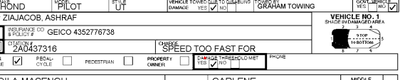

Example:
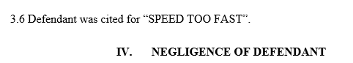

Step 6- Also as important as section 3, in this portion you will allege negligence.
- Always say or keep the portion that state “violating the rules of the road,” it’s a catchall.
- If defendant had a citation in the police report, list that again such as” Defendant was negligent for speeding, driving while intoxicated,………..”
  - MOST COMMON THINGS TO ADD TO THIS SECTION.
    - Defendant was negligent for- (some examples)
      - Failing to yield the right of way.
      - Following too closely (always used in rear end situations)
      - Unsafe turn
      - Improper lane usage
      - Inattention to driving.
      - Failing to stop

Step 7- DON’T CHANGE subsection 5 through the end of the complaint, including the “WHEREFORE” portion. I made the template gender neutral. If there are more parties then you’ll have to change stuff. Change the date at the bottom and you’re done.

Step 8- Use the ctrl F feature to search docs for terms you should have edited out. Such as the wrong gender pronouns, names, etc. Double check the footer and firm address is accurate. And TRIPLE check that the parties’ names in the heading are spelled correctly.

Drafting a Complaint UIM

Step 1- Complaints in UIM cases are somewhat different. Use the template. DOC 23.
Step 2- Change what is highlighted in general.
Step 3- For section 2.1, (I.e., Defendant insurance company), put the same location as Plaintiff’s residence (sec 1.1).
Note- LOOK AT 1P DECLERATION PAGE!!! Insurance companies have multiple names. The proper legal name will be listed on the declaration page. (EX: Geico “Choice/Direct/Advantage” Insurance Company)
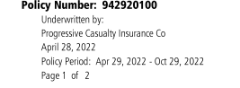

UIM Differences
Step 4- Sec 2.2 is very important. Change the Date of Incident, policy number which is on the declaration page, and the benefit amounts. Most clients will have $25k and $50. See pic below.

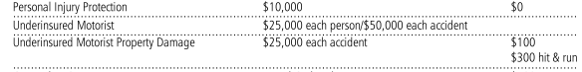
Step 5- Change the facts to the same as a regular complaint, but you wont mention the at fault party as a defendant. ALWAYS LEAVE/ADD THE LAST TWO SECTIONS. In my template its sections 4.8 and 4.9.
Step 7- leave sections 5 through the end alone. Only change the date at the bottom and you’re done.

Drafting a Complaint Trucking

Step 1- Open DOC 15, do the copy paste to new doc sequence.
- In General, change all portions that are highlighted, however do not rely solely on that as a form of editing. These complaints are long and vary much more on a case-by-case basis.
- These complaints are much more thorough and assertive.
- There are a lot of generalities concerning training, manuals, tests on employees, safety regulations, etc that need to be included. Do not remove these, just change the name of parties and potentially how they are involved (i.e., shipper, freight broker)
- Don’t purely say Defendant or Plaintiff throughout these complaints or any complaints that have multiple parties. Without an indicator like “Defendant Thiara” it will be very confusing for the Judge to read.
- There are a lot of repetitive allegations and information. It needs to be there, don’t delete it just because it has already been mentioned.
Step 2- Under subsection “II. PARTIES”, you will need to list out the parties. For Defendant companies, it’s a little more complicated. You will need the Annual Report shown below. This should already be on file in FV but it can be obtained from the Secretary of State website.
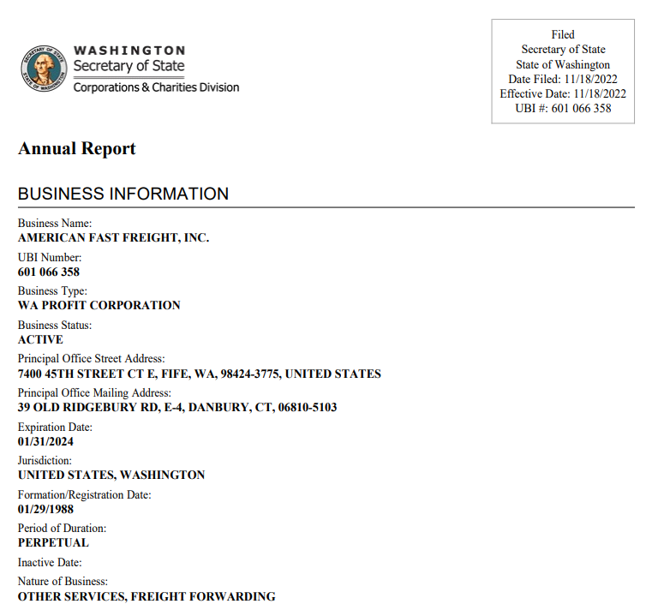
- You have to list where the company can be served, which is through the “Registered Agent” listed on Annual Reports. Put the person/company and that address.
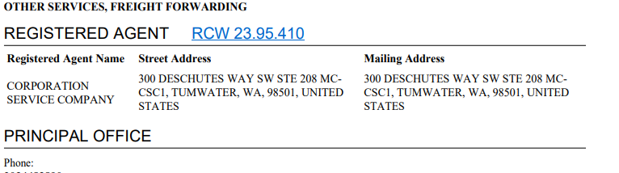

- You will also need to add the DOT # which is located in a number of places. Easiest is on a Police Report (see pic below) but also an annual report. You can also do a general search online on the US Dept of Transportation website for free.
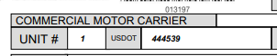
Step 3- Subsection “III. FACTS OF THE CRASH,”
- Leave the first line always (3.1)
- The structure and start of this story is much like a regular car accident complaint. See instructions above if you need further clarification.
- Always refer to the truck as tractor-trailer. Not truck or semi. The detail of the tractor-trailer can be found on police report. (in reference to line 3.3)

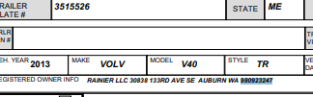

- (3.10-3.11) Change the name but these allegations are general and need to be included in all trucking complaints.
Step 4- Each party will have its own Negligence Allegation section. In my template it starts at “IV. Negligence of Defendant Sergey Frantsevich.”
- (4.2) If you are ever unsure about which allegations of negligence to apply, be liberal. It’s better to allege too much than too little. “Violating rules of the road” will function as a catchall regardless. Never remove that in any complaint ever.
- (4.5-4.6) leave that alone. It’s early in the case and we can allege anything and amend later.
Step 5- This is the party that directly employed the truck driver. LEAVE EVERYTHING THAT IN THE TEMPLATE. Change only the names. All of it is generally relevant to every trucking case.
Step 6- This is the “Freight Broker” in most cases. Same as step 6, just change names and the date of joint venture (6.4).
Step 7- change nothing else (i.e., Subsection “VII. NO OTHER AT FAULT PARTIES” through the end), just the date at the bottom and you’re done.

