**HOW TO WRITE A DEMAND LETTER**

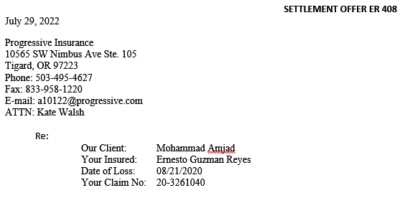

Each demand letter will be based on a template. This template will be the starting point for all demands.   
  
1) You may begin by including the date. Below that, you must provide the insurance details. To do so, you must establish whether it will be addressed to the 1st Party (1P) or 3rd Party (3P) insurance company. You may do so by checking the insurance tab on Filevine.

2) You must always include the insurance company name, its mailing address, and contact details for the adjuster. Fax number and e-mail addresses are particularly important. Some companies only accept demands via fax, other take them by e-mail.

3) If the demand letter is addressed to 3P insurance, “Our Client” and “Your Insured” will always contain different names. However, in the event of a 1P/UIM case, the insured will often be our own client, or the driver of the vehicle in which they were traveling.

4) Should you be unable to find any information, you can consult with the case manager or call the insurance company to find out.

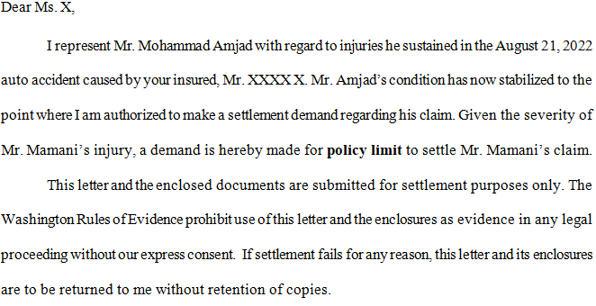

1) This is the standard formula. In UIM cases, you must change “the auto accident caused by your insured, Mr. …” to “the auto accident caused by an underinsured/uninsured driver”.

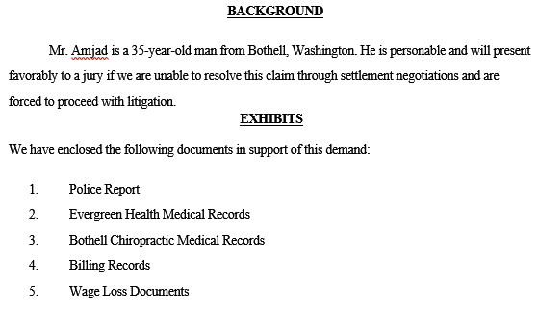

1) In the “Background” section, you must include the age and place of residence of our client. These can be found in the Intake tab or file.

2) “Exhibits” includes all documents we’ll enclose with the demand letter. The list follows a certain order. Police reports come first, if available. Then, you must list the different medical providers – hospitals, clinics, chiropractors – according to their first dates of service.

3) Finally, you must list the Billing Records and Wage Loss Documents, if any.

4) If there is only one medical provider, you do not need to list Billing Records separately (e.g. you may write “Bothell Chiropractic Medical & Billing Records”).

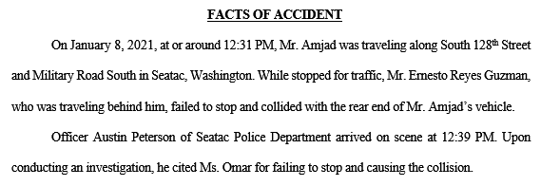

1) The facts of accident section can be written based on the description of the accident present in the Police Report, if available, or the one in the Intake tab or file.

2) You must include the date as well as the time, when available. You must list the road on which our client was traveling, as well as its intersection or block number.

3) Then, you must list how the accident took place, using one of the following formulas: “While continuing forward”, “While stopped for traffic”, “While stopped for a red light”, etc.

4) When a Police Report is available, you must list the name of the officer who filed it, his time of arrival, and whether he cited the other driver and on what charge. If not, then you can simply state that “Upon conducting an investigation, he filed a report”.

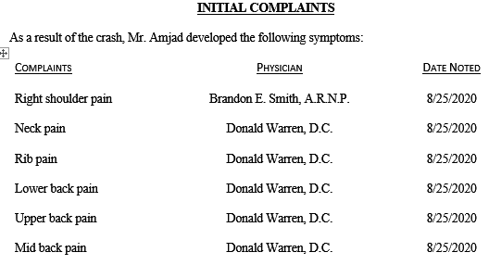

1) Initial complaints should be listed based on date noted. These are drawn from the subjective/HPI/initial complaints section of the first visit or initial exam and can be found within the medical records.

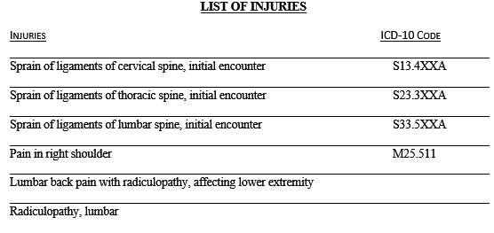

1) The list of injuries usually draws from the diagnoses present in the initial exam present in the chart notes. Some clinics list them in the billing records, however.

2) List them in order. If two or more clinics report the same diagnosis, list it only once.

3) You must include the ICD-10 code for the injury, if available on the medical records.

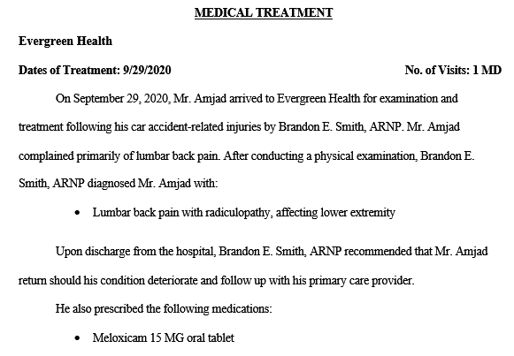

1) This is the template for all hospital/ER visits in the “Medical Treatment” section. You must include the date of service, all initial complaints, all relevant diagnoses, and any medication the client may have been prescribed as a result of the accident.

2) If there are multiple visits, you may change the final paragraph to reflect the number of total visits. In addition, even if the client was not treated by an MD, as is the case here, the “No. of Visits” will still be listed as MD visits.

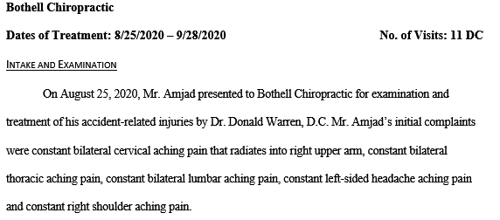

1) Chiropractic clinics will follow a different template. You must list the first and last date of treatment, the number of visits, and all initial complaints.

2) You must list massage therapy visits separately as “MT” visits, if applicable.

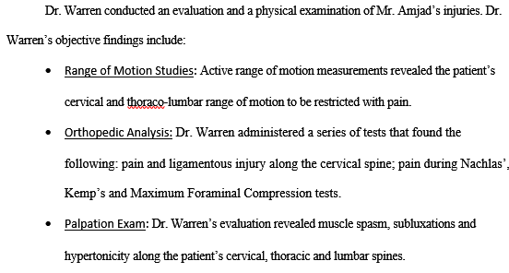

1) The number of visits can be drawn from the billing. List each date charged on a spreadsheet, and then write it down here. This section will draw from the objective findings of the initial exam. Range of Motion findings include those pertaining to the client’ spinal ROM; Orthopedic findings will stem from the chiropractor’s orthopedic tests; and Palpation findings will be present in all evaluations, too.

2) When radiographic impressions are available, you must also list them following the above pattern.

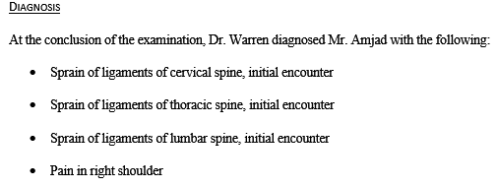

1) You must then list the diagnoses.

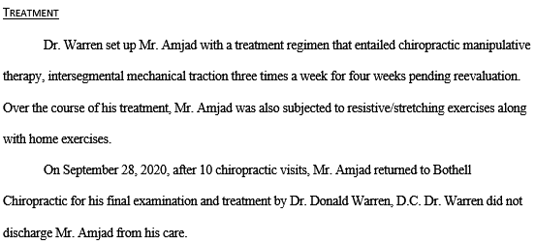

1) This section must include the kind of treatments the client underwent and their frequency. Finally, you must list the final date of treatment, how many visits there were prior to the final visit, and whether the client was discharged from care or not.

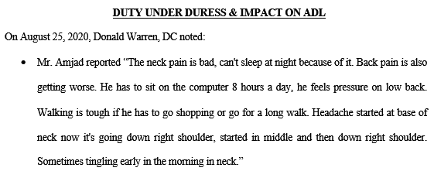

1) The “Duty Under Duress” section will include all the relevant aspects of the HPI/subjective aspects of the medical records. It details the symptoms and the impact the accident has had on our clients’ lives. There are usually notes for each visit. We list the symptom ratings and complaints; any reports of improvements are to be omitted.

2) Often, you will find that these chart notes cannot be subject to copy-paste. You may then use Sejda’s Optical Character Recognition (OCR) function on the relevant document. When doing so, make sure to double check the pasted text – it does get things wrong sometimes. As a last resort, you will have to transcribe them manually.

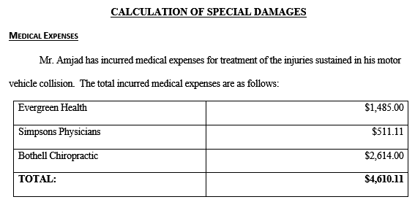

1) You must list the medical expenses. ER visits will often elicit a second bill for physicians’ services. Always check that.

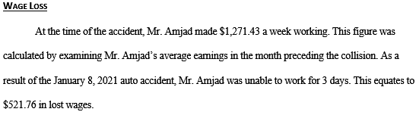

1) Wage loss, if available, will be calculated based on the gross pay presented on the client’s paystubs, and the number of work days they missed. The paystubs will be present on Filevine. The number of days of work they missed may be found a) in the communications section; b) the Wage Loss Authorization.

2) Use a spreadsheet to calculate the average daily pay, then multiply it by the amount of days of work they missed.

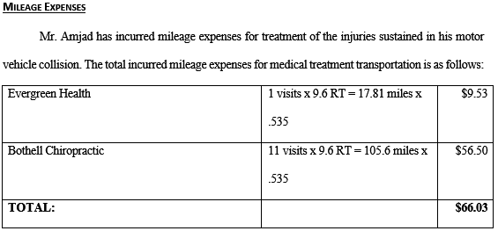

1) Mileage expenses are easy to calculate. Use the intake tab/file and Google Maps to determine the distance between the client’s house and the different clinic, calculate the roundtrip distance and follow the above template.

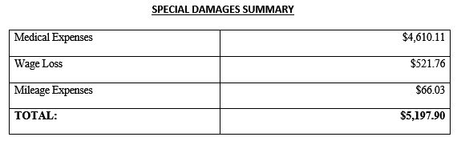

1) You must list the subtotal for every special damages section and calculate the total damages.

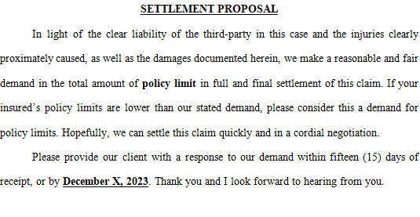

1) The settlement proposal will always be for policy limits.

2) The response and due by date is fifteen days from the date of writing.

**Other considerations**

You’ve finished the demand letter. Now you must assemble the package. Do so using Sejda.

1. Export the demand letter as a PDF.

2. Assemble the demand exhibits in the same order that you listed them and following the template.

3. Redact any insurance information from both chart notes and billing using the whiteout function in Sejda’s Edit Section.

4. Delete pages that do not pertain to chart notes or billing (e.g. fax covers, blank pages, etc.)

5. After assembling all exhibits, assemble the final demand package and send it to your team manager.